

**EGERTON UNIVERSITY**

**DEPARTMENT OF COMPUTER SCIENCE**

**[FACULTY OF SCIENCE]**

**COMP 493**

**ONLINE MOVIE THEATRE TICKETING SYSTEM**

**BY**

**MAINA PETER NDUNGU**

**S13/02330/19**

**SUPERVISOR**

**MR. KATIKU**

**APRIL 2023**

# **TABLE OF CONTENTS**

Contents

**TABLE OF CONTENTS** 2

**Abstract** 4

**CHAPTER1: PROPOSAL** 6

**1.1 INTRODUCTION** 6

**1.2PROBLEM STATEMENT** 8

**1.3PROJECT JUSTIFICATION** 8

**1.4RESEARCH QUESTIONS** 9

**1.5OBJECTIVES** 10

**CHAPTER2: PROPOSED SOLUTION** 11

**2.1 INTRODUCTION** 12

**2.2 REQUIREMENT ANALYSIS** 12

**2.3 PLANNING** 13

**2.4 ARCHITECTURAL DESIGN** 14

**JUSTIFICATION FOR THE METHODOLOGY** 15

**DATA COLLECTION APPROACHES** 15

**2.5DATA ANALYSIS AND TECHNIQUES** 16

**2.6FEASIBILTY STUDY** 16

**2.7 SOFTWARE DEVELOPMENT TOOLS** 18

**2.8TESTING** 18

**2.9 DEPLOYMENT** 20

**CHAPTER3: SOFTWATE REQUIREMENT SPECIFICATION** 21

**3.1 External Interface** 22

**3.2 Functional requirements** 23

**3.3Non-Functional Requirements** 24

**3.4 Domain Requirements** 24

**3.5 Database Requirements** 25

**3.6 Object Oriented Domain Analysis** 25

**3.7 SYSTEM MODELLING** 26

**CHAPTER4: SOFTWARE DESIGN DOCUMENT** 27

**4.1Introduction** 28

**4.2Scope** 28

**4.3Summary** 29

**4.4Glossary** 29

**4.5 System Architecture** 31

**4.5.1Software Architecture** 31

**4.5.2Hardware Architecture** 31

**4.6File and Database Design** 31

**4.6.1 Database design** 32

**4.6.2File Design** 33

**4.7Human Machine Interface** 34

**4.8Administrator interface** 42

**4.9Theatre assistant interface** 43

**4.10 Detail design** 44

**4.10.1Introduction** 44

**4.10.2System Overview** 44

**4.10.3User Interface** 44

**4.10.4Ticketing System** 45

**4.10.5Payment Processing System** 45

**4.10.6System Requirements** 45

**4.10.7Interaction between components** 46

**4.11 System Integrity Controls** 46

**CHAPTER 5: TEST PLAN** 47

**5.1 Introduction** 48

**5.2 Test Plan** 48

**5.2.1 Testing strategy** 48

**5.2.2Interface** 48

**5.3 Test Procedure** 49

**5.4 Test Resource Planning** 51

**5.5 Test Environment** 52

**5.6 Test Schedule and Estimation:** 54

**CHAPTER 6:USER MANUAL** 55

**6.1 System Requirements** 56

**6.2 System Requirements** 58

**6.3 System Features** 59

**6.4 System Support** 59

**CONCLUSION** 60

**REFERENCES** 60

# **Abstract**

The online movie theatre ticketing system is a web-based application designed to simplify the process of buying movie tickets for moviegoers. This system offers a convenient and user-friendly way to book tickets, select seats, and pay online. The system provides moviegoers with a convenient and secure way to book their tickets from anywhere and at any time. With the online ticket booking system, moviegoers no longer need to stand in long queues to buy their tickets. They can easily select their preferred movie and seats, make payments online, and receive their e-tickets via email or mobile app. For theatre owners, the online movie theatre ticketing system provides an efficient way to manage ticket sales, seat allocations, and showtimes. The system helps reduce the workload of theatre staff by automating the ticket booking process The online movie theatre ticketing system is designed to be user-friendly, secure, and scalable. It provides a secure payment gateway that enables users to make payments online without any fear of fraud. The system is built using several programming languages, frameworks, and libraries, depending on the specific requirements of the system, such systems include HTML, CSS, JavaScript, PHP, Java, and bootstrap. The system comes with a range of unique features that distinguish it from other online ticketing systems. For instance, it may pprovide real-time seat availability, so customers can quickly know if their desired seats are available or not. Additionally, the system has a live chat feature that customers can use to ask about available. Movies, queries regarding moving cancelling and refunds. To handle overbooking, the system can use a first-come, first-served basis or a reservation system that ensures customers get their tickets on time. For cancellations or refunds, the system provides a pportal where customers can cancel or refund their tickets, subject to certain terms and conditions. To ensure the privacy and security of customer data, the system has incorporated several measures such as encryption, data access control, and regular system updates. For small theatres, the system allows them to automate their ticketing processes, reduce queues and wait times, and increase their revenue. For large theatres, the system provides advanced features such as analytics, reporting, and integrations with other systems. The system can also be customized to meet specific needs and preferences of different theatres, such as branding, pricing, and loyalty programs.

# **CHAPTER1: PROPOSAL**

## **1.1 INTRODUCTION**

An online movie theatre system is an emerging concept that allow users to access movies online through the internet. This system provides users with a convenient and flexible way of watching movies, as they can do so from anywhere and at any time.

**Key Features**  
1.User Registration and Authentication

Users will be required to register and create an account to access the system. They will need to provide their name, email address, age, username, mobile number and password to create an account. Once registered they will be able to log in to the system and browse movies and purchase tickets online and also view their booking history.

2.Movie Browsing and Selection

Users will be able to browse movies by name. The system will offer a range of movies, from classic to new releases.

3.Ticket Purchasing.

Users will be able to purchase tickets for movies using their credit and debit cards. The system will ensure security of user data and payments by using SSL encryption and complying with PCI-DSS standards.

4.Admin Dashboard

The system will allow the admin to add upcoming movies, view users of the system, see users’ bookings, print reports of users’ bookings, add theatre and theatre screens and showtimes, seats and charges.

5.Theatre Assistant Dashboard

The theatre assistant will be able to add movies, delete movies, view movies, add shows, view current shows, view bookings made on a particular movie at the current date, view shows added and run or stop shows, view theatre details and also add theatre showtimes and screens, seats and charges.

**Benefits of online movie theatre system**

Convenience-users can access movies at anytime from anywhere at any time which eliminates the need to travel to a physical movie theatre.

Cost-effectiveness-online movie theatre systems usually offer more affordable pricing than traditional movie theatres which can attract budget-conscious customers.

**Challenges**

Need for high-speed connectivity-users need a stable internet connectivity which is fast to book and browse movies online which can be a challenge in areas with poor internet connectivity.

Online movie theatre systems can face technical glitches or outages which can frustrate users and harm their viewing experience.

• Computer literacy level: the intended customers may not possess the relevant ICT skills. to benefit from the proposed system. This may cause the company to some costs by offering to train their customers

• Limited system testing: improper unit and system testing may pose some usability issues such as delays in some modules.

## **1.2PROBLEM STATEMENT**

The traditional way of booking the ticket for the movie is the customer need to go to the specific theatre where the desired movie was playing and need to stand in queue and buy the ticket for the movie this will become more difficult for a person in order to overcome this problem The project gives real life understanding of online movie ticket booking system and activities performed by various roles in the supply chain. Here we provide automation for movie ticket booking system through internet. Online movie ticket booking system project captures activities performed by different roles in real life ticket booking which provides enhanced techniques for maintaining the required information up to date, which results in efficiency. The project gives real life understanding of online movie ticket booking system and activities performed by various roles in the supply chain.

## **1.3PROJECT JUSTIFICATION**

An online movie theatre booking system is an essential tool for both moviegoers and theatre owners. Here are some justifications for having such a system:

1. Convenience: An online booking system allows users to book tickets from anywhere at any time, without having to physically go to the theatre or stand in long queues. This makes it a convenient option for busy individuals who want to plan their movie outing in advance.
2. Improved customer experience: Online booking systems can provide users with detailed information about movie timings, seat availability, ticket prices, and special offers. This can enhance the overall customer experience and make it easier for customers to make informed decisions.
3. Increased efficiency: An online booking system can help theatre owners streamline their operations and reduce the workload on their staff. It can automate several tasks such as ticket booking, seat selection, and payment processing, which can save time and resources.
4. Data management: An online booking system can provide theatre owners with valuable data such as user preferences, booking patterns, and sales trends. This data can be used to improve marketing strategies and enhance customer engagement.
5. Competitive advantage: An online booking system can provide a competitive advantage to theatre owners by offering a seamless and hassle-free experience to users. It can also help theatre owners stay ahead of their competitors by providing a more efficient and user-friendly service.

## **1.4RESEARCH QUESTIONS**

1. What are the factors that influence customer satisfaction with online movie theatre booking systems?
2. How does the availability of online booking impact the frequency of movie theatre visits?
3. What are the most effective ways to market an online movie theatre booking system to customers?
4. What features of an online movie theatre booking system are most important to users?
5. How does the implementation of an online movie theatre booking system affect the operational efficiency of the theatre?

## **1.5OBJECTIVES**

The main objectives of the online system include:

* To provide a web-based movie ticket buying functions. Customer can buy movie ticket through the online system and no need to queue up to buy movie ticket
* To enable customer to check availability of movies online. Customer can check the time and date movie is featuring in the theatre, watch trailer, have description of movie, actors involved in movie, pricing of the movie and pay for movie ticket online.
* To ease the movie ticket payment by online. Customer has to pay the bus ticket by debit or credit card

Top of Form

Bottom of Form

# **CHAPTER2: PROPOSED SOLUTION**

## **2.1 INTRODUCTION**

The main purpose that theatres have been serving since their inception is to provide the tickets for the audience for the specified movie of specified show. While providing tickets, they also let us earn a certain amount of money based on the type of ticket we are booking. Traditionally the theatres will be on rush which wastes the time of the common man and hence by this system we can save the time and energy of the customer. The services offered by online movie ticket booking systems are

1. View the list of movies present

2. View the trailer of the movie

3. View the list of theatres based on the show

4. Book the ticket for the specified show

## **2.2 REQUIREMENT ANALYSIS**

Requirement analysis for an online movie theatre booking system typically involves identifying the key features and functionalities that the system should offer. Here are some of the common requirements that such a system should meet:

1. User registration and login: The system should allow users to create accounts and log in to the platform.
2. Movie selection: The system should provide a list of movies that are currently playing in the theatre, along with show timings and other relevant information such as the cast, synopsis, etc.
3. Payment gateway: The system should integrate a secure payment gateway that allows users to make payments online.
4. Booking confirmation: The system should provide users with a confirmation of their booking, along with the details of the show, the seats booked, and the payment made.
5. Seat availability: The system should provide real-time updates on seat availability for each show.
6. Cancelation and refund policy: The system should have clear policies regarding the cancelation and refund of bookings.
7. Search functionality: The system should have a search feature that allows users to find movies and shows based on different criteria such as name.
8. Analytics and reporting: The system could provide analytics and reporting features that allow theatre managers to track bookings, revenue, and other key metrics.

## **2.3 PLANNINGTop of Form**

PROJECT SCHEDULE This project will comprise all the activities involved in SDLC (see Fig 1).

All these activities have been summarized in a Gnatt chart below.

|  |  |  |  |  |  |  |  |  |  |  |  |  |  |  |
| --- | --- | --- | --- | --- | --- | --- | --- | --- | --- | --- | --- | --- | --- | --- |
| Weeks  activity | 1 | 2 | 3 | 4 | 5 | 6 | 7 | 8 | 9 | 10 | 11 | 12 | 13 | 14 |
| Problem  Definition |  |  |  |  |  |  |  |  |  |  |  |  |  |  |

|  |  |  |  |  |  |  |  |  |  |  |  |  |  |  |
| --- | --- | --- | --- | --- | --- | --- | --- | --- | --- | --- | --- | --- | --- | --- |
| Requirement  Identification |  |  |  |  |  |  |  |  |  |  |  |  |  |  |
| Analysis |  |  |  |  |  |  |  |  |  |  |  |  |  |  |
| Design |  |  |  |  |  |  |  |  |  |  |  |  |  |  |
| Implementation  On testing documenting |  |  |  |  |  |  |  |  |  |  |  |  |  |  |

## **2.4 ARCHITECTURAL DESIGN**

This system underwent all the stages of system development lifecycle (SDLC). According to the nature of this system and the data collected, a waterfall methodology was used to develop this system. This methodology included the following stages: feasibility study, requirement analysis and specification design, coding, testing, integration then maintenance. Each phase required a different amount of effort and every phase had a well-defined starting and point. Every phase had to be completed before beginning the next stage.

Feasibility study

Requirement analysis and specification

Design

Coding

Testing

Integration

Maintenance

## **JUSTIFICATION FOR THE METHODOLOGY**

The waterfall methodology was worthwhile because this approach produced a complete quality system and error-free system due to the fact that every phase had to be completed before the next one began thus leaving no phase unattended.

However, according to the data collected on the user requirements, there was a clear understanding of the user requirement hence no doubt on what was to be developed.

Similarly, the approach was also less costly since there was no repeating of a process once completed and thus minimized wastage of resources as compared to other approaches such as the rapid prototyping methods.

## **DATA COLLECTION APPROACHES**

So as to collect data from Modern coast bus ticket booking system as well as its clients, appropriate methods of collecting data were needed. These techniques included the following:

**Observations**

This involved the researcher going to the field of study, making direct watch on the way the organization under study operates, identifying the possible drawbacks of the operating system analysing the problems and developing a solution based on the observations made. This technique was employed since it provides a first-hand information which is quite reliable and accurate since the method provided a quick overview of the system. It is the most effective technique.

**Interviews**

This is a direct face to face conversation between the system analyst(interviewer) and the users of the system. This was used where the respondents were few in order clarifying and verifying gathered facts. This technique was important to use since some data could not be collected by direct observation unless interviewed, hence it helped in enriching the data for quality processing

**Questionnaires**

A questionnaire refers to a set of questions prepared by the person collecting data in a paper which is issued to specific people who in turn respond to the questions privately without the presence of the interviewer. Once the respondent is through, he/she will issue the answers back to the person collecting the data. This technique was also important because some interviewees were not confident enough to respond to the question at the interview panel during the interview, and therefore a questionnaire best suited such people.

## **2.5DATA ANALYSIS AND TECHNIQUES**

Data analysis is the process of evaluating data using analytical and logical reasoning to examine each component of data provided. Data from various sources was analysed after being gathered and reviewed so as to come up with conclusion. The current system was evaluated using the gathered facts or information. These tools included be the following: Use of tables and charts

## **2.6FEASIBILTY STUDY**

The feasibility study was intended to examine the current system and determine whether there was need for a new system to replace it or not. It tended to check whether the current system was viable. Basically, this was meant to analyse the feasibility of a new system through cost-benefit analysis. It included: Legal feasibility, operational feasibility, economic feasibility, technical feasibility and schedule feasibility

**Social Operational Feasibility**

This is a measure of how well a proposed system solves the problems, and takes advantage of the opportunities identified during scope definition and how it satisfies the requirements identified in the requirements analysis phase of system development. It dealt with the effect of the system on the current society within the company.The operational feasibility assessment focused on the degree to which the proposed development projects fitted in with the existing business environment and objectives with regard to development schedule, delivery date, corporate culture, and existing business processes. To ensure success, desired operational outcomes were imparted during design and development. These included such design-dependent parameters such as reliability, maintainability, supportability, usability, predictability, disposability, sustainability, affordability and others. These parameters were considered at the early stages of design where desired operational behaviors ere to be realized. A system design and development required appropriate and timely application of engineering and management efforts to meet the previously mentioned parameters. A system may serve its intended purpose most effectively when its technical and operating characteristics are engineered into the design. Therefore, operational feasibility is a critical aspect of systems engineering that needed to be an integral part of the early design phase. The Online movie theatre ticket booking system solutions was found reliable and adaptable therefore making it operationally feasible.

**Legal Feasibility**This study was conducted to determine whether the proposed system conflicted with legal requirements. This is where data processing system must comply with the Local Data Protection Acts. Any legal aspects associated with the new system were assessed and then adequate measures taken to protect the interest of clients at Modern coast bus ticket booking system.

The Online movie theatre ticket booking system Solutions went through this stage successfully and the system was found feasible.

**Economic feasibility**

The purpose of the economic feasibility assessment was to determine the positive economic benefits to the organization that the proposed system had to provide. It included quantification and identification of all the benefits expected. This assessment typically involved a Cost-Benefits Analysis (CBA). Undoubtedly the Online Movie theatre ticketing system was found economically feasible and no possibility of it outliving its usefulness in the near future.

**Technical Feasibility**

The assessment focused on gaining an understanding of the present technical resources of ticket booking sector and their applicability in the proposed system. This was aimed at evaluating both hardware and software required for the new system. It also determined whether the current facilities were adequate for the new system implementation.

**Schedule Feasibility**

Schedule feasibility is a measure of how reasonable the project timetable is. The project would fail if it took too long to be completed before it is useful. However, this means estimating how long the system would take to develop, and if it can be completed in a given time period using some methods like payback period. According to the time schedule of this system, it was clear that the project would be scheduled feasible since it would take approximately 3 months which was a relatively short period for such a system

## **2.7 SOFTWARE DEVELOPMENT TOOLS**

**Programming Tools**

PHP and HTML were used for coding purposes as they served best during web-based applications. JAVA SCRIPT was also employed for scripting purposes while CSS was used to format the web pages and creating appealing and user-friendly interfaces of the system. NOTEPAD++ editor was used to edit the code.

**Database Tools**

For database creation and connection purposes XAMPP was used which also has PHP MYADMIN for database management and hosting.

**System Modelling Tools**

Data flow diagrams, sequence diagrams and use case diagrams were some of the system modelling tools that would be used to draw in the development process

## **2.8TESTING**

Testing of an online movie theatre booking system is critical to ensure that the system meets its functional and non-functional requirements and is ready for deployment. Here are some of the key types of testing that should be conducted for an online movie theatre booking system:

1. Functional testing: This type of testing focuses on verifying that the system meets its functional requirements. It includes testing the various features of the system such as user registration and login, movie selection and search, seat selection, payment processing, booking confirmation, cancelation and refund policy, and loyalty programs.
2. Usability testing: This type of testing focuses on the user experience of the system. It includes testing the user interface, navigation, and accessibility features. Usability testing helps to identify any issues that could negatively impact the user experience, such as confusing or hard-to-use interfaces.
3. Performance testing: This type of testing focuses on the system's performance under different loads and conditions. It includes testing the response time of the system, the scalability of the system, and the system's ability to handle high traffic volumes.
4. Security testing: This type of testing focuses on identifying any security vulnerabilities in the system. It includes testing the system's authentication and authorization mechanisms, data encryption, and protection against common security threats such as SQL injection and cross-site scripting.
5. Compatibility testing: This type of testing focuses on ensuring that the system works correctly across different devices, operating systems, and web browsers. Compatibility testing helps to identify any issues that could arise due to differences in device configurations.
6. Regression testing: This type of testing involves retesting the system after changes have been made to ensure that no new issues have been introduced. Regression testing is important to ensure that the system continues to work as expected after updates or changes have been made.
7. User acceptance testing (UAT): This type of testing involves testing the system with a group of end-users to ensure that the system meets their needs and expectations. UAT helps to identify any usability issues or gaps in functionality that may have been missed.

## **2.9 DEPLOYMENT**

Deploying an online movie theatre booking system involves several steps, including the following:

1. Choose a hosting provider: The system needs to be hosted on a server so that it can be accessed by users. You can choose a hosting provider that offers the necessary resources, such as storage, bandwidth, and security features.
2. Select the appropriate deployment environment: Depending on the system's requirements, you can choose a deployment environment such as a dedicated server, virtual private server (VPS), cloud-based service, or a containerized environment like Docker.
3. Set up the server environment: Once you have selected the deployment environment, you need to set up the server environment. This includes installing the necessary software and configuring the server settings. You also need to ensure that the server environment is secure by installing firewalls, SSL certificates, and other security measures.
4. Deploy the application: Once the server environment is set up, you can deploy the application to the server. This involves transferring the application files to the server and configuring the server to run the application.
5. Test the deployment: Once the application is deployed, you need to test it to ensure that it works correctly in the server environment. This includes testing the application's functionality, performance, and security.
6. Monitor the system: After the deployment is complete, it is essential to monitor the system to ensure that it is running smoothly. This includes monitoring server performance, application performance, and user activity.
7. Maintain and update the system: To ensure that the system remains secure and up-to-date, you need to perform regular maintenance and updates. This includes updating the software, applying security patches, and performing backups.

# **CHAPTER3: SOFTWATE REQUIREMENT SPECIFICATION**

The purpose of the online movie theatre booking system is to provide a convenient and user-friendly platform for customers to book movie tickets online. The system should allow users to search for movies, select seats, make payments, and receive booking confirmation. The system should also have features for managing the movie schedules, seat availability, and user accounts.

The scope of the online movie theatre booking system includes the following:

1. User management: The system should allow users to create accounts, log in, and manage their profiles. Users should be able to view their booking history, loyalty points, and payment details.
2. Movie management: The system should allow movie theatre administrators to manage movie schedules, ticket prices, seat availability, and showtimes. The system should also allow the administrators to add new movies and update existing ones.
3. Booking management: The system should allow users to search for movies, select seats, and make payments. The system should also send booking confirmation to the user’s dashboard.
4. Payment management: The system should be integrated with payment gateways to allow users to make payments securely. The system should also have features for refunding and cancelling bookings.
5. Reporting: The system should provide administrators with reports on movie bookings.

The SRS for the online movie theatre booking system will provide a clear understanding of the system's requirements, including its functionality, performance, usability, and security. The SRS will serve as a guide for the development team and will help ensure that the final product meets the stakeholders' expectations.

## **3.1 External Interface**

The external interfaces for an online movie theatre booking system are the ways in which the system interacts with external entities, including users, other systems, and devices. The external interfaces are critical components of the system, and they need to be designed carefully to ensure that they are reliable, secure, and easy to use. Here are some of the external interfaces for an online movie theatre booking system:

An external interface for an online movie theatre booking company would typically include several key components to ensure a seamless user experience for customers. These components may include:

1. User Registration and Login: This component allows users to create an account and log in to access the movie theatre booking service. Users can also save their personal information, such as their name, contact details, and payment information, to make future bookings faster.
2. Movie Search and Booking: The movie search and booking component allows users to search for movies by various criteria such as movie name, date, and time. Once a user has found a movie they want to watch, they can book tickets for the showtime of their choice.
3. Payment Gateway: The payment gateway component is a critical part of the external interface, enabling secure online payments for movie ticket bookings. Users can pay using various methods such as debit card, credit card, or net banking.
4. Booking Confirmation and Ticket Generation: Once the user has completed the booking and payment process, the booking confirmation and ticket generation component generates an electronic ticket that the user can print.

Top of Form

## **3.2 Functional requirements**

These requirements are those that enable the system to operate. These requirements focus mainly on what the system should do. They include:

* Users have to register themselves by creating accounts to gain access to the system’s services.
* User authentication by use of password.
* The system has two database views; the super administrator has more privileges than the other users. The system shall validate users accessing data in the system through use of password and username validation and verification. A login dialog box will be used for these purposes.
* The categories of users allowed to access data in the system are:

1. Administrator,
2. Theatre Administrator

iii) Customers (clients)

The super Admin will be responsible for making changes to the database while the members will only be allowed to view the contents of the database.

## **3.3Non-Functional Requirements**

These requirements focus on how the system works or how the system should behave by providing its quality attributes. These requirements include:

* The system should be able to handle an unlimited number of users at a time.
* Documentation: the system will be documented and PDF manuals will be available for users when the system goes live.
* Recover-ability: the system will be regularly backed up so that it can be recovered in case data is lost for some reason.
* Design constraints: The software will be developed with MySQL database back end.
* The system will not work in the absence of internet
* The system will only require the registered users to log in to the system.
* The system will only allow the super admin to change data on the database and not any other user.

## **3.4 Domain Requirements**

* This system will not be in a position to operate in environments which are not accessible to internet
* The system will also require the user to have access to a computer/a laptop, a smart phone or any other device that has internet access.
* The system will be by those people basic computer skills.
* People with visual impairments will not use the system unless there is assistance from people without visual challenges.

## **3.5 Database Requirements**

* A common repository of data will be needed. This implies that the new system will require a database for data storage and retrieval for the purposes of processing and feedback information.
* The database will require a number of tables to record various entries that the uses will enter into the system.

## **3.6 Object Oriented Domain AnalysisTop of Form**

Object-oriented domain analysis is a process that involves identifying the various objects, classes, and relationships that make up a system. In the case of an online movie theatre booking system, the following objects and classes can be identified:

1. User: This class represents the users of the system who can book movie tickets, view movie schedules, and provide feedback. The user class may have attributes such as name, email, password, and payment information.
2. Movie: This class represents the movies that are being shown in the theatre. The movie class may have attributes such as title, genre, language, duration, and rating.
3. Theatre: This class represents the physical theatre that is showing the movies. The theatre class may have attributes such as location, number of screens, seating capacity, and show timings.
4. Ticket: This class represents the tickets that user’s book to watch a particular movie in a particular theatre. The ticket class may have attributes such as seat number, price, and booking date.
5. Booking: This class represents the booking made by a user for a particular movie in a particular theatre. The booking class may have attributes such as booking ID, date, and time.

In addition to the above classes, the following relationships can be identified:

1. User-Movie: A user can view the details of a movie, search for movies, and book tickets for a particular movie.
2. Movie-Theatre: A movie is shown in a particular theatre at a particular time

Top of Form

**333**

## **3.7 SYSTEM MODELLING Top of Form**

Top of Form

In this section, diagramming tools are used to help users understand the flow of data for the existing system of operationn of online movie theatre ticketing system. Since the system is a manual one, figure 4 below illustrates the activities that take place with the current system at online movie theatre ticketingg system when a client is booking.

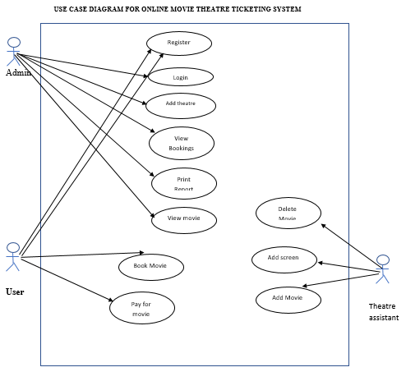

# **CHAPTER4: SOFTWARE DESIGN DOCUMENT**

## **4.1Introduction**

This document outlines the software design for an online movie theatre system. The purpose of the system is to allow users to browse and purchase movie tickets, view movie schedules, and make reservations for their preferredseats.

## **4.2Scope**

The scope of the SDD for the online movie theatre ticketing system will include the following:

1. User registration and login: The system will allow users to create an account and log in to the system to browse and purchase movie tickets.
2. Movie and showtime browsing: The system will provide an interface for users to search and select movies, view movie details such as synopsis, rating, genre, cast and crew, and check showtimes at their preferred theatre location.
3. Ticket reservation: The system will allow users to reserve tickets for their preferred showtime and select their preferred seats in the theatre.
4. Payment processing: The system will handle payment processing securely and efficiently, allowing users to purchase movie tickets using a variety of payment options.
5. Order confirmation: The system will generate a confirmation email and display a summary of the user's order, including showtime, seat selection, and payment information.
6. User account management: The system will provide users with the ability to manage their account information, including viewing their order history, updating personal information, and changing their password.
7. Theatre location management: The system will allow administrators to add, edit, and remove theatre locations, including theatre name, address, phone number, and seating capacity.
8. Movie management: The system will allow administrators to add, edit, and remove movie details, including title, synopsis, rating, genre, cast and crew, and trailer.
9. Showtime management: The system will allow administrators to manage showtimes, including adding, editing, and removing showtimes for movies at different theatre locations.

## **4.3Summary**

The software design document for online movie theatre ticketing system is a detailed technical document that describes the software design and architecture of the system. The document includes high-level system overview, system architecture, and component level design. It also includes information about the system requirements, design patterns, data structures and algorithms used in the system. SDD provides a detailed description of the software design for the front-end, back-end, and database components of the system, as well as how they interact with each other. It also includes details about user interface, system security, and testing and deployment plans. SDD serves as a blueprint for the software development team to implement and test the system.

## **4.4Glossary**

Glossary of online movie theatre ticketing system:

1.PHP: PHP stands for Hypertext Pre-processor. It is a server-side scripting language used for web development.

2.MySQL: MySQL is a relational database management system that is used to store and retrieve data for web applications.

3.XAMPP: XAMPP stands for Cross-Platform, Apache, MySQL, PHP, and Perl. It is an open-source software package that includes all the necessary components to run a web server on a local computer.

4.Web application: A web application is a software program that is accessed through a web browser and runs on a web server.

5.Front-end: The front-end of a web application refers to the part of the application that is visible to the user and is responsible for handling user interactions.

6.Back-end: The back-end of a web application refers to the part of the application that is responsible for managing data, processing requests, and generating responses.

7.User: A user is a person who interacts with the web application and performs various actions such as browsing, searching, and purchasing tickets.

8.Authentication: Authentication is the process of verifying the identity of a user and ensuring that they are authorized to access the system.

9.Authorization: Authorization is the process of granting access to a user based on their identity and role.

10.Role-based access control: Role-based access control is a security mechanism that restricts access to resources based on the role of the user.

11.Data encryption: Data encryption is the process of converting sensitive data into an unreadable format to prevent unauthorized access.

12.HTTPS: HTTPS stands for Hypertext Transfer Protocol Secure. It is a secure communication protocol that encrypts data sent between a web server and a web browser.

13.Input validation: Input validation is the process of verifying that user input is valid and does not contain malicious code such as SQL injections or cross-site scripting attacks.

14.Error handling: Error handling is the process of identifying and handling errors that occur during the execution of the web application.

15.Audit trail: An audit trail is a record of all user activities performed within the system.

16.Back-up and recovery: Back-up and recovery are the processes of creating copies of data to protect against data loss and restoring data from backups in the event of a disaster.

17.Patch management: Patch management is the process of regularly applying software updates to address security vulnerabilities and improve system performance

## **4.5 System Architecture**

The system architecture of an online movie theatre ticketing system includes both software and hardware components.

### **4.5.1Software Architecture**

The software architecture of the system is based on the Model-View-Controller (MVC) design pattern. The front-end component is developed using HTML, CSS and JavaScript. The back-end component is developed using PHP, which runs on the Apache web server. The database component uses MYSQL to store all user, movie, theatre and ticket information.

### **4.5.2Hardware Architecture**

The hardware architecture of the system includes a web server and a database server. The web server is responsible for handling user requests and providing responses. It hosts the front-end and back-end components of the system. The database server stores all the data and is responsible for processing all database-related requests.

The system is designed to be scalable and fault-tolerant. Load balancing techniques can be used to distribute traffic across multiple web servers. Database replication techniques can be used to ensure data consistency and provide fault tolerance in case of a database server failure.

## **4.6File and Database Design**

The file and database design for the online movie theatre ticketing system is an important aspect of the software design document. The system uses a MYSQL relational database to store and manage all the data related to users, movies theatres and tickets.Top of Form

### **4.6.1 Database design**

The database schema consists of several tables, each designed to store specific types of data. The main tables include:

* + tbl_registration: This table stores all user information, including their name, age, email-address, phone-number and gender.
  + tbl_login: This table stores user email-address, password and user type.
  + tbl_movie: This table stores movie information, including theatre id, movie id, movie name, movie-cast, movie-description, movie-release date, movie-trailer and movie-image.
  + tbl_news: This table stores upcoming movies information like name, cast, description, image and upcoming movie release date.
  + tbl_theatre: This table stores theatre information including name, address, place, state and pin.
  + tbl_shows: This table stores show information, including movie id, theatre id, start date and status of movie if running or not running.
  + tbl_screens: This table stores theatre screens information like screen name, number of seats, and charges.
  + tbl_showtime: This table stores show times information like screen id, showtime name, and start time of movie.
  + tbl_bookings: This table stores booking details information like ticket id, user_id, show_id, screen_id, number of seats booked, amount paid, booking date, and ticket date.

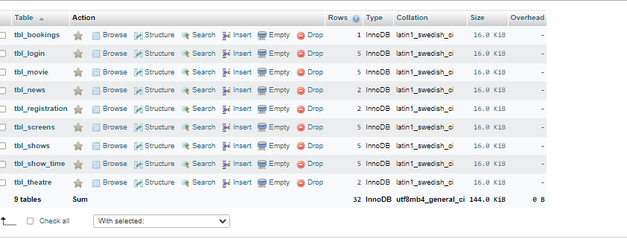

View of the database of online movie theatre ticketing system

### **4.6.2File Design**

The file design for the Online movie theatre ticketing system includes the following components:

**1.index.php**: The main file that includes the login and registration functionality for the customer. It also provides the customer interface for viewing movie lists.

**2.about.php**: The file that provides the customer interface for viewing movie title, movie image, showtimes, movie cast and description, watch trailer of movie and theatre where movie is showing.

**3.booking.php**: This file provides the customer interface for booking seats, amount, showtimes, theatre where movie is showing, date for booking, movie image, cast, description and image.

**4.process_booking.php**: This file provides customer interface for movie payment.

**5.bank.php**: This file provides customer interface for booking confirmation.

**6.profile.php**: This file provides customer interface for viewing booking details he/she has made on a movie and provides a cancellation option for booked movie.

**7.config.php**: This file includes the database connection details and other configuration parameters.

**8.index.php in admin file:** The file that provides the administrator interface for managing theatres, upcoming movies, view booking details and reports.

**9.index.php in theatre file**: The file that provides theatre assistant interface for managing movies, shows, showtimes and theatres.

**10**.**styles.css:** The file that includes the CSS styles for the customer and administrator interfaces.

## **4.7Human Machine Interface**

The human machine interface for online movie theatre ticketing system includes the following interfaces:

1.Customer interface

2.Administaror interface

3.Theatre assistant interface

**Customer Interface**

The customer interface allows customers to search for movies, theatres, showtimes, select seats, make payments, and receive booking confirmation

1. Login and Registration page:

Customers can register and login to access the system

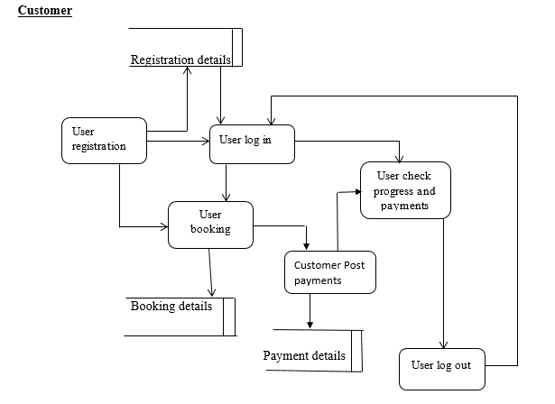

**Data flow diagram for customer**

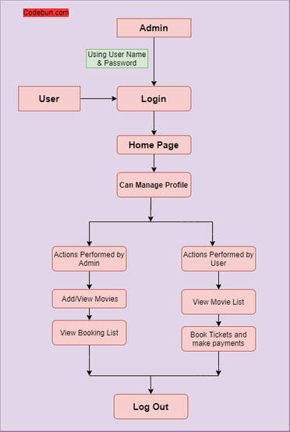

**Flow chart for admin**

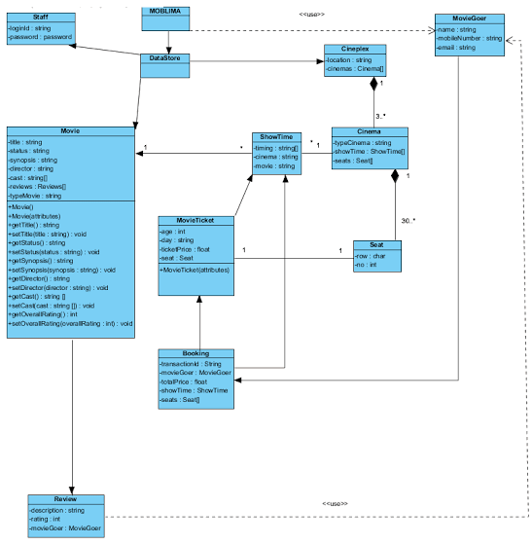

**Entity diagram for online movie theatre ticketing system**

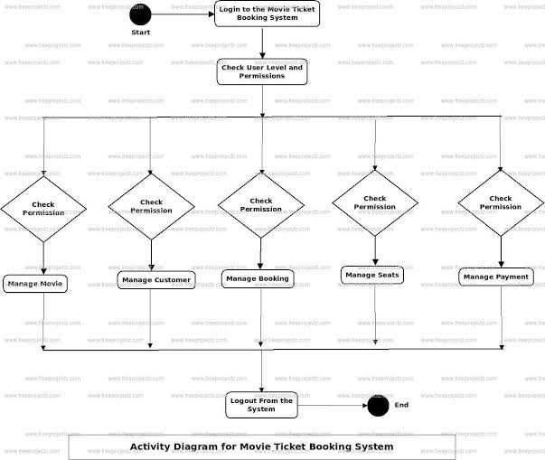

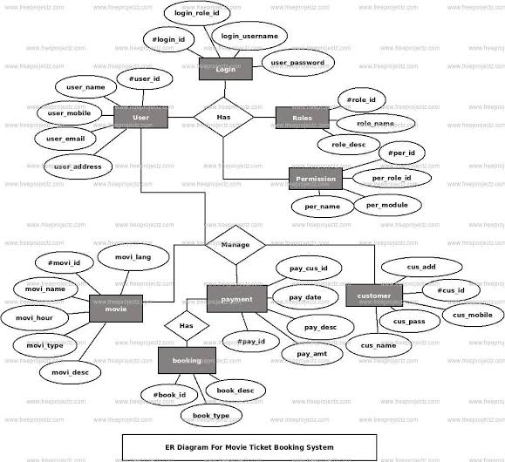

2.Movie List Page: 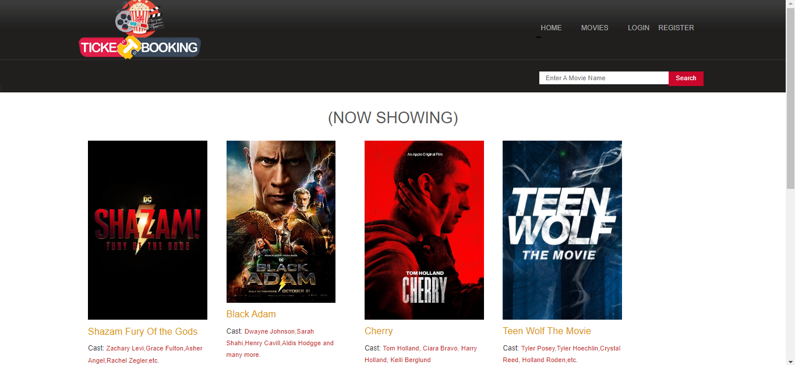

Customers can view a list of movies playing at different theatres.

3.Theatre List page:

Customers can view a list of theatres that are playing the selected movie.

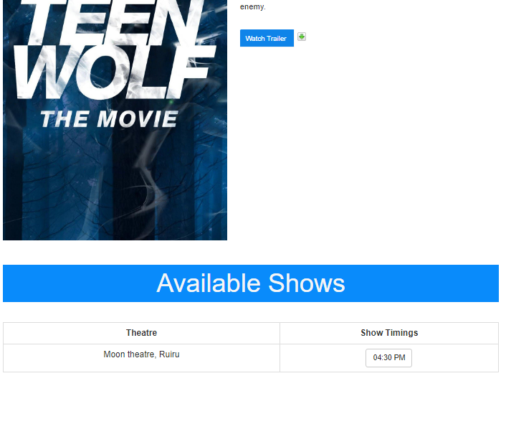

4.Showtime page:

Customers can view available showtimes for the selected movie and theatre.

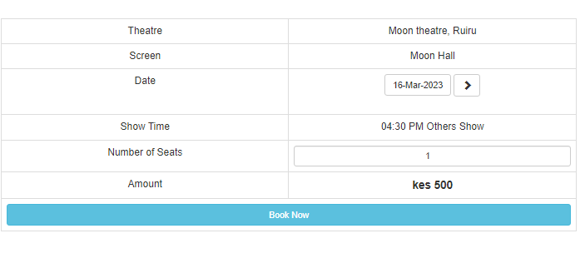

5.Payment page

Customers can make payment for the selected seats

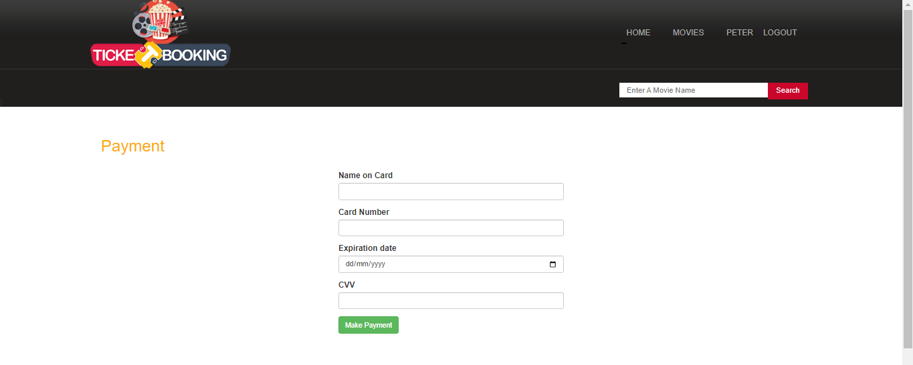

6.Booking confirmation page:

Customers can receive a confirmation page with the booking details.

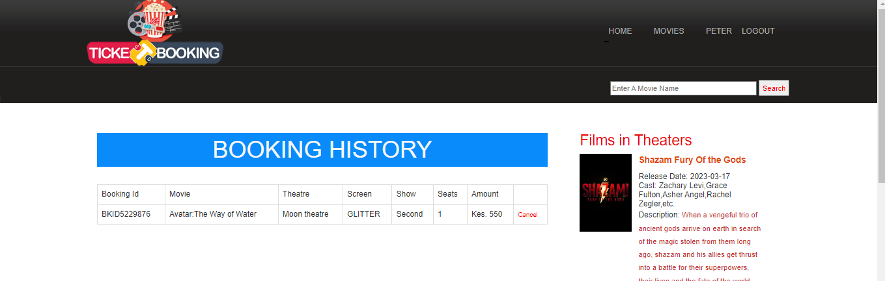

## **4.8Administrator interface**

The administrator interface allows administrators to view movies, add theatres, add upcoming movies, view members, view booking details and reports.

1.Login page: Administrators can log in to access the system

2.Dashboard: Administrators can view a summary of the system including the movies list, adding theatre, adding upcoming movies, manage users, view reports and booking details.

3.Theatre management: Administrators can manage theatres, including adding theatres, adding theatre screens, adding charges and number of seats in theatres.

4.Management of upcoming movies: Admin can add upcoming movies

5.Member management: Admin can view total number of registered users of the system, view their booking details and generate a report of their bookings.

Preview of the Admin Dashboard

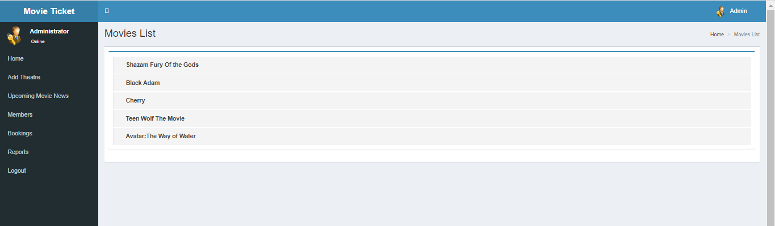

## **4.9Theatre assistant interface**

The theatre assistant interface allows administrators to view movies, add movies, delete movies, view today bookings, view today shows and manage theatre.

1.Login page: Theatre assistant can log in to access the system

2.Dashboard: Theatre assistant can view a summary of the system including the movies list, adding movies, deleting movies, manage theatres, view today bookings and today shows.

3.Theatre management: Theatre assistant can manage theatres, including, adding theatre screens, adding charges and number of seats in theatres.

4.Management of movies: Theatre assistant can add movies and also delete movies.

Preview of theatre assistant interface

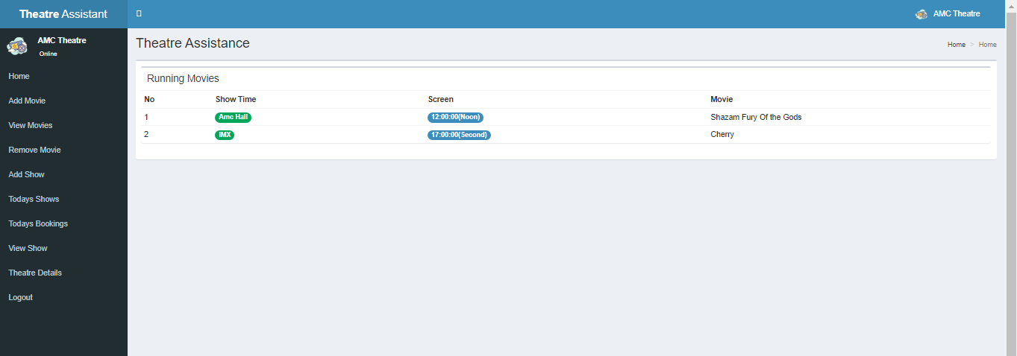

## **4.10 Detail design**

### **4.10.1Introduction**

The purpose of this software design document is to provide a detailed overview of the design of an online movie theatre ticketing system. This document outlines the system architecture, software components, system requirements, and how each component interacts with one another to form a cohesive functioning system

### **4.10.2System Overview**

The online movie theatre ticketing system is designed to provide users with the ability to purchase tickets for movie screenings at their convenience. The system consists of three main components: the user interface, the ticketing system and payment processing system.

### **4.10.3User Interface**

The user interface is the front-end component of the system that users interact with to purchase movie tickets. The user interface is designed to be intuitive and easy to use with features such as movie selection, showtime selection, and seat selection. The user interface is also responsible for displaying movie information, pricing and availability.

### **4.10.4Ticketing System**

The ticketing system is the back-end component of the system that handles the ticket purchasing process. The ticketing system is responsible for managing inventory, updating seat availability in real time and generating tickets for users. The ticketing system also handles user authentication, including account creation and login.

### **4.10.5Payment Processing System**

The payment processing system is responsible for securely handling user payments for movie tickets. The payment processing system is designed to be secure and reliable, with support for credit card payment method. The payment processing system is also responsible for generating for users.

### **4.10.6System Requirements**

. The system must support multiple movie theatres with different showtimes and seats.

. The system must support multiple users each with their own account and login credentials

. The system must provide users with the ability to select seats for their chosen movie screenings.

. The system must handle user payments securely and reliably.

. The system must be scalable to support large number of user and movie theatres.

The following are the software components that make up the online movie theatre ticketing system

. User Interface: The user interface is built using HTML, CSS and JavaScript and is designed to be responsive and accessible to multiple users.

. Ticketing System: The ticketing system is built using PHP and is responsible for managing inventory, updating seat availability in real time and generating tickets for users.

. Payment Processing System: The payment processing system is built using a third-party payment processing service such as stripe, and is responsible for securely handling user payments.

### **4.10.7Interaction between components**

The user interface interacts with the ticketing system via a set of APIS provided by the ticketing system. The user interface sends requests to the ticketing system to retrieve mobile information, pricing, availability, as well as to select seats and purchase tickets. The ticketing system updates seat availability in real time and generates tickets for users.

The payment processing system interacts with the ticketing system to handle user payments. When a user purchases tickets, the payment processing system sends a request to the ticketing system to update the inventory and generate tickets. The payment processing system also generates tickets for users.

## **4.11 System Integrity Controls**

User Authentication: A secure user authentication system is implemented to authenticate users’ identities and prevent unauthorized access to the system.

Access Controls: Access controls is implemented to limit users’ access to only the functions and data they need to perform their jobs. It has incorporated role-based access control, where uses are granted, access based on their job functions and responsibilities.

Audit Trails: All user activity and system occurrences are to be audited. This includes tracking user actions, system events, and system configuration changes.

# **CHAPTER 5: TEST PLAN**

## **5.1 Introduction**

The purpose of this test plan is to provide a comprehensive guide for testing the online movie theatre ticketing system. The goal is to ensure that the system functions as expected, meets the requirements of the stakeholders, and provides a seamless user experience.

This test plan will cover various aspects of the system, including functionality, usability, security, and performance. It will outline the testing approach, test cases, and tools to be used during the testing process. The test plan will also define the roles and responsibilities of the testing team and provide a timeline for the testing process.

The ultimate goal of this test plan is to identify and address any defects or issues before the system is released to the public. By ensuring that the system is thoroughly tested, we can provide a high-quality product that meets the needs of our customers and stakeholders.

## **5.2 Test Plan**

### **5.2.1 Testing strategy**

**Unit testing**: This sort of testing focuses on ensuring that individual components or modules of system function as intended.

**Performance Testing:** Performance testing of an online movie theatre ticketing system involves testing the system's ability to handle a large volume of users, transactions, and requests while maintaining its functionality, stability, and responsiveness.

**Functional Testing:** This type of testing ensures that the system functions as intended and meets all the business requirements.

**Retest and Regression Testing:** Retesting ensures that the issues discovered during testing have been resolved, while regression testing ensures that the new changes have not introduced any new defects or broken the existing functionality.

### **5.2.2Interface**

Here are some key aspects to consider when developing the interface in the test plan:

1. Navigation: Test the navigation of the interface to ensure that users can easily find the information they need and navigate between different pages and sections of the system.
2. Usability: Test the usability of the interface to ensure that it is user-friendly, easy to understand, and follows industry-standard design principles.
3. Responsiveness: Test the responsiveness of the interface to ensure that it is optimized for different screen sizes and devices, including desktops, laptops, tablets, and smartphones.
4. Accessibility: Test the accessibility of the interface to ensure that users with disabilities can use the system without any issues. Verify that the interface is compliant with the Web Content Accessibility Guidelines (WCAG) and other industry standards.
5. Consistency: Test the consistency of the interface to ensure that the design elements, layout, and functionality are consistent throughout the system, providing a unified user experience.

## **5.3 Test Procedure**

**Unit Testing:** Here are some examples of unit tests that could be performed on an online movie theatre ticketing system:

1.User authentication: Test the login functionality to ensure that only authorized users can access the system. This could involve testing the validation of the username and password, as well as any other security features such as two-factor authentication.

2.Movie selection: Test the functionality that allows users to browse and select movies they want to see. This could involve testing the search and filter features to make sure they return accurate results, as well as the functionality that allows users to view movie details and trailers.

3.Seat selection: Test the functionality that allows users to select seats for their chosen movie. This could involve testing the seat map and selection process to ensure that seats are correctly displayed and that users can easily select the seats they want.

4.Payment processing: Test the functionality that allows users to make payments for their ticket purchases. This could involve testing the integration with payment gateways, as well as testing for any errors that might occur during the payment process.

5.Ticket generation: Test the functionality that generates and delivers tickets to users. This could involve testing the accuracy of the information on the ticket, as well as testing the delivery methods such as email or SMS.

**Performance Testing:** Here are some key steps involved in the performance testing of an online movie theatre ticketing system:

1.Define Performance Requirements: The first step is to define the performance requirements for the system. This includes determining the expected number of users, transactions, and requests that the system should be able to handle, as well as the response time and throughput required to provide a satisfactory user experience.

2.Create Test Scenarios: Test scenarios should be created that simulate the expected user behavior, such as the number of concurrent users accessing the system, the number of tickets being purchased at once, and the peak hours of usage.

3.Execute Performance Tests: Performance tests are executed using load testing tools that simulate a large number of concurrent users and transactions. The tests should be run with various configurations and scenarios to ensure that the system can handle different levels of load and usage patterns.

4.Analyze Results: After the tests are executed, the results should be analyzed to identify any bottlenecks, performance issues, or areas for improvement. This may involve analyzing server response times, transaction rates, resource utilization, and other performance metrics.

5.Optimize the System: Based on the results of the performance tests, the system may need to be optimized to improve its performance, scalability, and reliability. This may involve making changes to the hardware, software, or network infrastructure, or improving the code and database performance.

6.Retest and Validate: Once the system has been optimized, it should be retested to validate the improvements and ensure that the system can handle the expected load and usage patterns. This may involve repeating the performance tests with the same or new test scenarios and configurations.

**Functional Testing:** Here are some key areas to consider when conducting functional testing for the online movie theatre ticketing system:

1.User interface: Test the user interface to ensure that it is intuitive, easy to use, and meets the requirements of the end-users. Verify that the system follows the industry-standard design principles and is accessible to all types of users.

2.Login and registration process: Test the login and registration process to ensure that users can easily create an account and log in to the system. Verify that the system can authenticate user credentials correctly, including email verification, password reset, and account recovery processes.

3.Movie selection and payment options: Test the movie selection process to ensure that users can search for movies, view showtimes, select seats, and purchase tickets quickly and easily. Verify that the payment process is secure, reliable, and integrates with different payment gateways.

4.Confirmation and cancellation process: Test the confirmation process to ensure that users receive confirmation messages after purchasing tickets and that the system handles cancellations and refunds correctly.

5.User management: Test the user management features to ensure that administrators can manage user accounts, roles, and permissions easily. Verify that the system can handle user data securely and protects users' privacy.

6.Reporting and analytics: Test the system's reporting and analytics features to ensure that administrators can view essential metrics, such as ticket sales, revenue, and occupancy rates, and generate custom reports easily.

**Retest and Regression Testing:** Here are some key steps to follow when conducting retesting and regression testing for the online movie theatre ticketing system:

1. Identify the areas to be retested: Identify the areas of the system that were previously defective and have been fixed by the development team.

2. Conduct retesting: Retest the areas identified in the previous step to ensure that the issues have been resolved.

3. Conduct regression testing: Conduct regression testing on the entire system to ensure that the new changes have not introduced any new defects or broken the existing functionality.

4. Develop a regression test suite: Develop a regression test suite that includes all the test cases from the previous testing cycles and additional test cases for the new features and functionality.

5. Automate regression testing: Consider automating regression testing to save time and reduce the risk of human error. Automation tools can help run regression tests faster and more efficiently.

6. Monitor the test results: Monitor the test results to identify any issues that may have been missed during testing. Document all the issues and report them to the development team for resolution.

7. Repeat the cycle: Repeat the retesting and regression testing cycles until all the issues are resolved and the system meets all the business requirements.

## **5.4 Test Resource Planning**

Here are some steps that can help in test resource planning:

1. Identify the types of resources needed: The first step is to identify the types of resources needed to run the online movie theatre ticketing system. These resources may include hardware resources such as servers, storage devices, and networking equipment, as well as software resources such as web servers, databases, and application servers.
2. Determine the capacity requirements: Once the types of resources have been identified, it is important to determine the capacity requirements for each resource. This may include factors such as the number of concurrent users, the number of movies being screened, the number of tickets being sold per day, and so on.
3. Estimate the resource usage: Based on the capacity requirements, it is possible to estimate the resource usage for each resource. For example, the estimated resource usage for a server may include the number of CPU cycles, the amount of memory used, and the amount of disk space required.
4. Test the system under load: To ensure that the system can handle the estimated resource usage, it is important to test the system under load. This may involve simulating a large number of concurrent users, generating a high volume of ticket sales, and so on. The test should be run over a period of time to ensure that the system can handle sustained usage.
5. Monitor resource usage: During the test, it is important to monitor the resource usage of each resource to ensure that it does not exceed its capacity. If any resource usage exceeds its capacity, it may cause system instability or downtime.
6. Optimize resource allocation: Based on the results of the test, it may be necessary to optimize the allocation of resources. For example, it may be necessary to allocate more resources to the web server if it is the bottleneck in the system.
7. Repeat the test periodically: Resource planning is an ongoing process, and it is important to repeat the test periodically to ensure that the system can handle increased usage over time. This may be necessary as the number of users, movies, and tickets sold increases.

## **5.5 Test Environment**

**Hardware and Software Requirements:**

Web server with database support

Load balancing server (optional)

Application server

Operating system (OS) for servers and clients

Browser for client access

Internet connectivity for both client and server

Database management system (DBMS)

**Test Data:**

Sample movie titles with their respective showtimes, theaters, and prices

Test user account information with different permission levels

Sample payment information (e.g., credit card numbers)

**Security Protocols:**

Secure Socket Layer (SSL) for data encryption

Authentication and authorization protocols

Firewall and intrusion detection systems

Regular security audits and vulnerability assessments

**Test Environment Setup:**

Install and configure the necessary hardware and software components

Configure the web server, application server, and database server

Install and configure the load balancing server (if used)

Install and configure the security protocols

Populate the database with sample data

Configure user accounts and permission levels

Set up payment gateway integration (if used)

**Test Scenarios:**

Test the user registration process

Test the login and authentication process

Test the ticket booking process, including seat selection and payment

Test the cancellation process

Test the search functionality for movies, theaters, and showtimes

Test the display of movie details and theater information

Test the display of seat availability and pricing

Test the email and SMS notifications for booking confirmation and cancellation

Test the reporting and analytics functionalities, such as ticket sales and revenue reports

Test the performance and scalability of the system under heavy load (e.g., multiple concurrent users)

## **5.6 Test Schedule and Estimation:**

**Test Schedule:**

Test Planning and Preparation: 1 week

Unit Testing: 3 weeks

Functional Testing: 3 weeks

Performance Testing: 2 weeks

Retest and Regression Testing: 2 weeks

Total Test Duration: 11 weeks

**Test Estimation:**

Test Planning and Preparation: 1 Tester x 1 week = 1 Tester-week

Unit Testing: 2 Testers x 3 weeks = 6 Tester-weeks

Functional Testing: 3 Testers x 3 weeks = 9 Tester-weeks

Performance Testing: 2 Testers x 2 weeks = 4 Tester-weeks

Retest and Regression Testing: 2 Testers x 2 weeks = 4 Tester-weeks

Total Test Effort: 24 Tester-weeks

Note: Test estimation may vary depending on various factors such as the complexity of the system, the size of the team, the availability of resources, etc. Also, the test schedule mentioned above is just a high-level estimate, and it may change based on the results obtained during the testing process.

# **CHAPTER 6:USER MANUAL**

## **6.1 System Requirements**

**Q: How do I create an account on the movie theatre ticketing system?**

A: To create an account, simply visit the website and click on the "Register" button. You'll be prompted to enter your personal information such as your name, email address, and a password. Once you submit the information, you'll receive a confirmation email to activate your account.

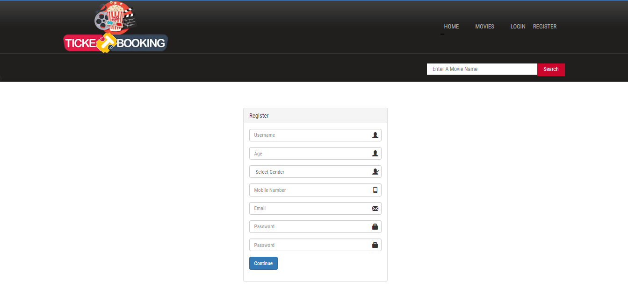

**Q: How do I book a movie ticket?**

A: To book a movie ticket, log in to your account and search for the movie you want to see. Once you find the movie and showtime, select the number of tickets you need, and proceed to payment.

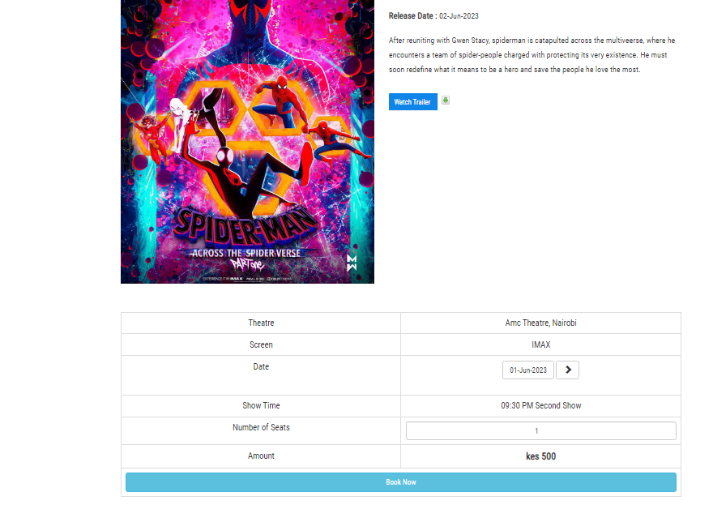

**Q: What payment methods are accepted for booking movie tickets?**

A: We accept all major credit and debit cards, as well as online payment platforms such as PayPal and Stripe.



**Q: Can I cancel my movie ticket booking?**

A: Yes, you can cancel your movie ticket booking, but it depends on the cancellation policy of the theatre. Some theatres offer refunds for cancellations made up to a certain time before the show, while others do not offer refunds. Check the cancellation policy before booking.

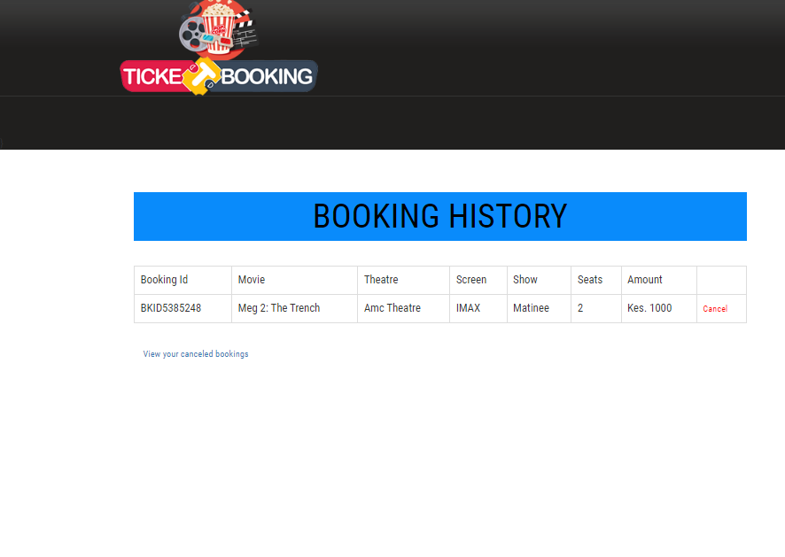

**Q: Can I book tickets for movies showing in the future?**

A: Yes, you can book tickets for movies showing in the future. Simply select the date and time you want to see the movie, and proceed to payment.



**Q: Can I print my movie ticket at home?**

A: Yes, some theatres allow you to print your movie ticket at home. Check the booking confirmation email for instructions on how to print your ticket.

**Q: What should I do if I have a problem booking my movie ticket?**

A: If you have a problem booking your movie ticket, contact customer support through live chat. They will be able to assist you with any issues you may be having.

## **6.2 System Requirements**

Here are the system requirements for our online movie theatre ticketing system:

1. **Device:** You can access our online movie theatre ticketing system through any device with internet connectivity, including desktop computers, laptops, tablets, and smartphones.
2. **Web browser:** To use our platform, you will need a web browser such as Google Chrome, Mozilla Firefox, Safari, or Microsoft Edge. It is recommended that you use the latest version of your preferred web browser for the best user experience.
3. **Internet connectivity:** You must have a stable internet connection to access our platform and purchase movie tickets online. A minimum internet speed of 5Mbps is recommended to ensure a seamless experience.
4. **Payment method:** You must have a valid credit or debit card to purchase movie tickets on our platform. We accept Visa, MasterCard, and American Express.
5. **Email account:** You must have a valid email account to create an account and receive your movie ticket reservation confirmation.
6. **Printing or digital device:** You can choose to either print your movie ticket reservation or use a digital device such as a smartphone or tablet to display your reservation QR code at the theatre for admission.
7. **Operating System:** Our platform is compatible with various operating systems such as Windows, MacOS, iOS, and Android. Ensure that your device's operating system is up to date for optimal performance.

## **6.3 System Features**

User-friendly interface:

Our platform has a user-friendly interface that makes it easy for you to browse movies, select showtimes, and purchase tickets.

1. **Account management**: Our system allows you to create and manage your account, including updating your personal details, viewing your ticket reservation history, and canceling or modifying your ticket reservations.
2. **Real-time seat selection**: Our platform provides real-time seat selection, allowing you to choose the specific seats you want to reserve for your movie.
3. **Payment processing:** Our system uses a secure payment gateway to process credit and debit card payments for your movie ticket reservations.
4. **Email confirmation:** After purchasing your movie tickets, our system sends you an email confirmation containing your ticket reservation details, including the movie title, showtime, and seat number.
5. **Customer support:** Our platform provides customer support via email or phone to assist you with any issues or questions you may have with your ticket reservation.

## **6.4 System Support**

1. **Customer support**: We provide customer support via email and phone to assist you with any issues or questions you may have with your ticket reservation. You can contact our customer support team during business hours, and we will respond to your inquiry as soon as possible.
2. **User manual**: We provide a user manual that guides you through the steps necessary to use our system. The manual contains information on creating an account, browsing movies and showtimes, selecting seats and ticket quantities, payment processing, and checking in at the theatre.
3. **System updates:** We regularly update our system to ensure that it is operating smoothly and efficiently. These updates may include bug fixes, security patches, and new features that enhance your user experience.
4. **Feedback:** We value your feedback and suggestions on how we can improve our system. You can send us your feedback via email, and we will take it into consideration for future updates to our platform.

# **CONCLUSION**

In conclusion, an online movie theatre ticketing system can revolutionize the way moviegoers’ book and attend movies. With the convenience of online booking, customers can save time and effort by avoiding long queues and waiting times. The system also benefits theatre owners by providing an efficient way to manage bookings, inventory and revenue.

By implementing a user-friendly and secure online ticketing system, movie theatres can increase customer satisfaction and loyalty, ultimately leading to increased profitability. Additionally, the integration of advanced features such as real-time seat selection, easy payment options, and personalized recommendations ca enhance their overall user experience.

Overall, an online movie theatre ticketing system provides a win-win situation for both customers and theatre owners. It enables a hassle-free booking experience for customers while providing a streamlined and efficient management system for theatre owners. As technology continues to evolve, such systems will become increasingly commonplace and essential for the success of movie theatres.

# **REFERENCES**

1. Turban, E., & Volonino, L. (2017). Information technology for management: digital strategies for insight, action, and sustainable performance. John Wiley & Sons.
2. Laudon, K. C., & Laudon, J. P. (2019). Management information systems: managing the digital firm. Pearson Education Limited.
3. O'Brien, J. A., & Marakas, G. M. (2018). Management information systems. McGraw-Hill Education.
4. Sun, X., Yan, H., & Ma, J. (2018). Research on online ticketing system design for movie theater based on cloud computing. In 2018 2nd International Conference on Computer Science and Artificial Intelligence (pp. 141-145). IEEE.
5. Geetha, M., & Venugopal, K. R. (2015). Movie ticket booking system using Android OS. In 2015 International Conference on Advances in Computing, Communications and Informatics (ICACCI) (pp. 2188-2193). IEEE.
6. Shetty, R. S., & George, S. (2017). Online movie ticket booking system using Android. In 2017 International Conference on Inventive Communication and Computational Technologies (ICICCT) (pp. 1161-1165). IEEE.
7. Liu, Z., Yang, H., & Ren, F. (2019). Research on development of intelligent movie theater online booking system. In 2019 International Conference on Computer, Information and Telecommunication Systems (CITS) (pp. 1-6). IEEE.
8. Jung, H. J., Kim, Y. J., & Ko, S. G. (2015). A study on the design of online ticket booking system for cultural events. Journal of Digital Convergence, 13(7), 221-227.
9. Chand, D. K., & Jayalakshmi, N. (2019). Movie ticket booking system: A comparative study of online and offline modes of booking. International Journal of Recent Technology and Engineering, 8(2S3), 327-331.
10. Lee, M. (2018). The impact of service quality on customer satisfaction in online movie ticket booking systems. International Journal of Services and Operations Management, 31(2), 216-233.
11. Bhatia, A., & Arora, M. (2019). A conceptual framework for adoption of online movie ticket booking system. International Journal of Scientific Research and Management, 7(3), 52-57.
12. Odeh, R. A., Al-Khaldi, M. M., & Al-Mobaideen, W. A. (2020). Examining the intention to use mobile ticketing systems: the case of cinema ticket booking. Journal of Systems and Information Technology.
13. Khurana, R., & Gupta, R. K. (2018). A comparative analysis of movie ticket booking through offline and online mode. International Journal of Engineering and Technology, 7(3), 293-297.
14. Chen, Y. S., & Liang, G. S. (2019). Design of mobile movie ticket booking system based on wechat. In 2019 6th International Conference on Behavioral, Economic, and Socio-Cultural Computing (BESC) (pp. 1-5). IEEE.